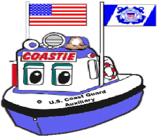
WATER N’ KIDS
United States Coast Guard Auxiliary
Flotilla Name
City, State
Flotilla Contact Information

A MESSAGE TO PARENTS AND FAMILY MEMBERS:

Your child participated in a presentation by the United States Coast Guard Auxiliary that covered three important subjects for everyone living near a waterway environment. The subjects are swimming safety, boating safety, and protecting the marine environment.

The specific areas of emphasis are:

- Only go near the water when an adult is with you.
- Always swim with a buddy and only in a designated swimming area.
- Become a strong swimmer.
- Wear a properly fitting life jacket when going boating.
- Stay seated when the boat is moving.
- Stay off the sides, bow, and back of the boat when it is moving.
- Be a lookout to help avoid collisions.
- Stay with the boat in case of an accident, and the boat flips over.
- Do not throw trash or plastic materials of any kind into the water.
- Take an approved boating safety class when old enough.

It has been proven that swimming and boating safety education of young children helps to reduce accidents and fatalities when swimming and boating. Your child’s school has taken an important step in helping students expand and enhance their school safety programs.

If you would like information about boating safety courses, free vessel safety exams, or membership in the United States Coast Guard Auxiliary, please visit our website or call the number below.

Your Flotilla Contact Number
Your Flotilla Website

